External Tool Config:
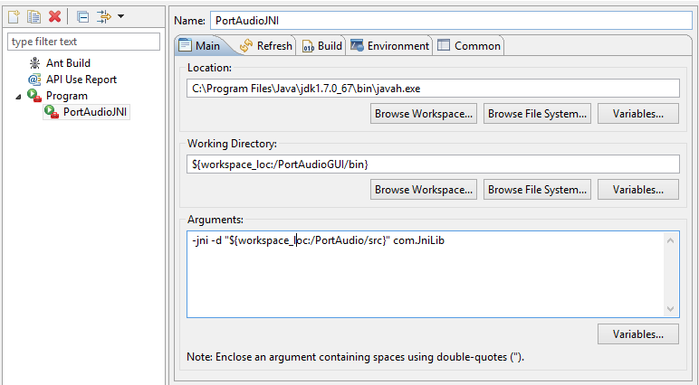

Run Configurations:
Added VM arg
-Djava.library.path="C:\\Users\\Dan\\Documents\\Eclipse\\PortAudioGUI\\res"

For error “can't load 32-bit whatever in AMD 64 ...”
Under Window → Preferences-->Java → installed JREs ----- added Java 32-bit

